L.E.N.S. FOCUS
L – Literacy
E – Educators’
N – Network of
S - Saskatchewan

(formerly the Saskatchewan Reading Council)
MARCH, 2018
Focus: Writing – How to Get the Most out of Independent Writing Time
Do you and your students struggle with various aspects of the writing process?
How familiar are the following comments?
“I don’t know what to write!”
“How long does this have to be?”
“Am I done?” (ugh!)
“Is this good enough?”
“Can you read this?”
“Yes, I ‘recopied’ it.”
Etc., etc.

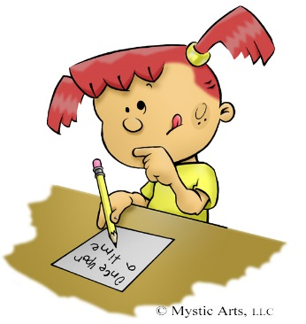

Struggle no more!

There are lots of resources out there to rescue you!

In today’s LENS focus, we will look at a few ways your fellow teachers have rallied their students over the writing slump…

- Engagement: authentic audiences such as a letter actually mailed to someone, poetry to be shared at a “Coffee House” poetry sharing, a speech to be given to an audience, a persuasive essay to ask the principal to make changes in the school…
The list goes on! Make sure your students are writing in order to engage someone real in their thinking! Why am I writing this piece?

- Actual Writing: pencils sharp, no distractions, no dictionaries, etc… and GO!
Write. Just write. Don’t stop writing. Don’t check spelling. Don’t read something. Don’t confer with a partner. Don’t go to the bathroom. Don’t illustrate. JUST WRITE. Writing is a muscle that needs to be exercised and strengthened. If your students can only write for 3 minutes without disrupting themselves, push them to 4, and so on.

- Revising: This is a great place to look at the Six Traits of Writing (see rubric below.)
Of course your students likely won’t analyze and improve every trait for every piece of writing, but it’s important to remember that ALL the traits TOGETHER contribute to a strong piece. Take a look at our “Young Saskatchewan Writers” publication – you will see good evidence of all those traits. Probably the one that gets the most attention when choosing a piece to publish is “VOICE.”
Check out this Powerpoint that explains the Six Traits:

- Editing: What looks “okay” to students may look like a horror show of mistakes to their teachers. However, with auto-correct and texting, this is not going to improve without visual to help kids remember what to look for in order to have a “clean” piece of writing. Let them edit and fix a few things without it becoming an overwhelming task…

Check out the following:

Courtesy of Adrienne Gear- “1-2-3-4… Check it!” (Primary):
Revision and Editing
- FIX one spelling mistake
- CHANGE a word that doesn’t sound right
- ERASE a word (or words) that doesn’t fit
- ADD a word (or words) to make your writing better.

And “3-2-1 Check It!” (Intermediate) – in which students only HAVE to fix 6 things!
3, 2, 1 – Check It!
- – Convention correction
- Spelling, punctuation, spacing
- – Word Wind-up
- Add, erase, replace
- Sentence Shake-up 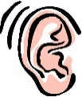
- Make a whole sentence sound better
Star-Wish-Think Conference
Name ___________ Date ________
Conference Partner - ______________________
– Tell something you like about the writing. (compliment)
____________________________________________________
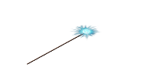 – Give the writer a wish for their writing. (suggestion)
_____________________________________________________

- Explain something that the writing makes you think about. (connection)
And, free your students to edit on their own or with partners after mini-lessons on MINTS and PATS, using the following anchor charts:
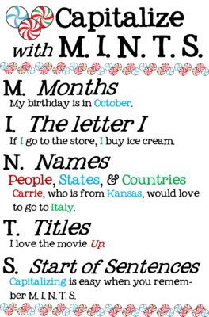
Paragraphing

Use the P-A-T-S strategy when deciding when to start a new paragraph. What does this mean?

Start a new paragraph when:

P-the (p)lace changes

A-the (a)ction changes

T-the (t)ime changes

S-the (s)peaker changes

Why would a writer need to indent?

- To indicate when a change is coming in the story.
- To help readers organize the story in their minds.
- To provide a place to pause and reflect.
- To assist readers in finding their place when they lose them while reading.

Six Traits Writing Rubric
Good luck, and happy writing!
 | 6  Exemplary | 5  Strong | 4  Proficient | 3  Developing | 2  Emerging | 1  Beginning
Ideas & Content  main theme  supporting details | • Exceptionally clear, focused, engaging with relevant, strong supporting detail | • Clear, focused, interesting ideas with appropriate detail | • Evident main idea with some support which may be general or limited | • Main idea may be cloudy because supporting detail is too general or even off-topic | • Purpose and main idea may be unclear and cluttered by irrelevant detail | • Lacks central idea; development is minimal or non-existent
Organization  structure  introduction  conclusion | • Effectively organized in logical and creative manner  • Creative and engaging intro and conclusion | • Strong order and structure  • Inviting intro and satisfying closure | • Organization is appropriate, but conventional  • Attempt at introduction and conclusion | • Attempts at organization; may be a “list” of events  • Beginning and ending not developed | • Lack of structure; disorganized and hard to follow  • Missing or weak intro and conclusion | • Lack of coherence; confusing  • No identifiable introduction or conclusion
Voice  personality  sense of audience | • Expressive, engaging, sincere  • Strong sense of audience  • Shows emotion: humour, honesty, suspense or life | • Appropriate to audience and purpose  • Writer behind the words comes through | • Evident commitment to topic  • Inconsistent or dull personality | • Voice may be inappropriate or non-existent  • Writing may seem mechanical | • Writing tends to be flat or stiff  • Little or no hint of writer behind words | • Writing is lifeless  • No hint of the writer
Word Choice  precision  effectiveness  imagery | • Precise, carefully chosen  • Strong, fresh, vivid images | • Descriptive, broad range of words  • Word choice energizes writing | • Language is functional and appropriate  • Descriptions may be overdone at times | • Words may be correct but mundane  • No attempt at deliberate choice | • Monotonous, often repetitious, sometimes inappropriate | • Limited range of words  • Some vocabulary misused
Sentence Fluency  rhythm, flow  variety | • High degree of craftsmanship  • Effective variation in sentence patterns | • Easy flow and rhythm  • Good variety in length and structure | • Generally in control  • Lack variety in length and structure | • Some awkward constructions  • Many similar patterns and beginnings | • Often choppy  • Monotonous sentence patterns  • Frequent run-on sentences | • Difficult to follow or read aloud  • Disjointed, confusing, rambling
Conventions  age appropriate, spelling, caps, punctuation, grammar | • Exceptionally strong control of standard conventions of writing | • Strong control of conventions; errors are few and minor | • Control of most writing conventions; occasional errors with high risks | • Limited control of conventions; frequent errors do not interfere with understanding | • Frequent significant errors may impede readability | • Numerous errors distract the reader and make the text difficult to read

