OUTDOOR SCAVENGER HUNT
(PLAYGROUND)
GROUP MEMBERS: __________________________
Please find the following, with your group helping:
(Check off the box when you find each item.)
You have _45__ minutes to complete the quest.
A three-coloured rock

Your whole group on top of something
taller than you

A feather Glass that isn’t too
sharp
Two teachers hugging A piece of plastic

A pine cone A dead branch (DON’T break 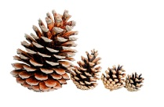 one off) 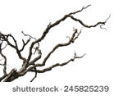
Yourselves in a human pyramid
An unbroken leaf Something purple

Something star-shaped

Blade of grass A seed
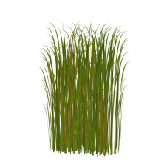

Y-shaped twig 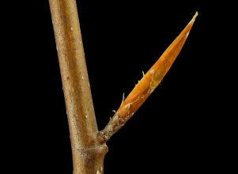

An animal 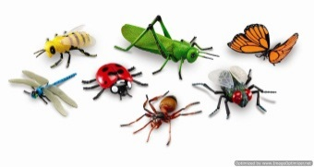

Mrs. (Admin Assistant) or Mme (Vice Principal) or Mrs. (Principal) giving “thumbs-up”

You must bring everything back in your bag.
If something can’t be brought in, please photograph it.

